**Forskningsdagene: ChatGPT vs lege**

**Left middle cerebral artery territory infarct**

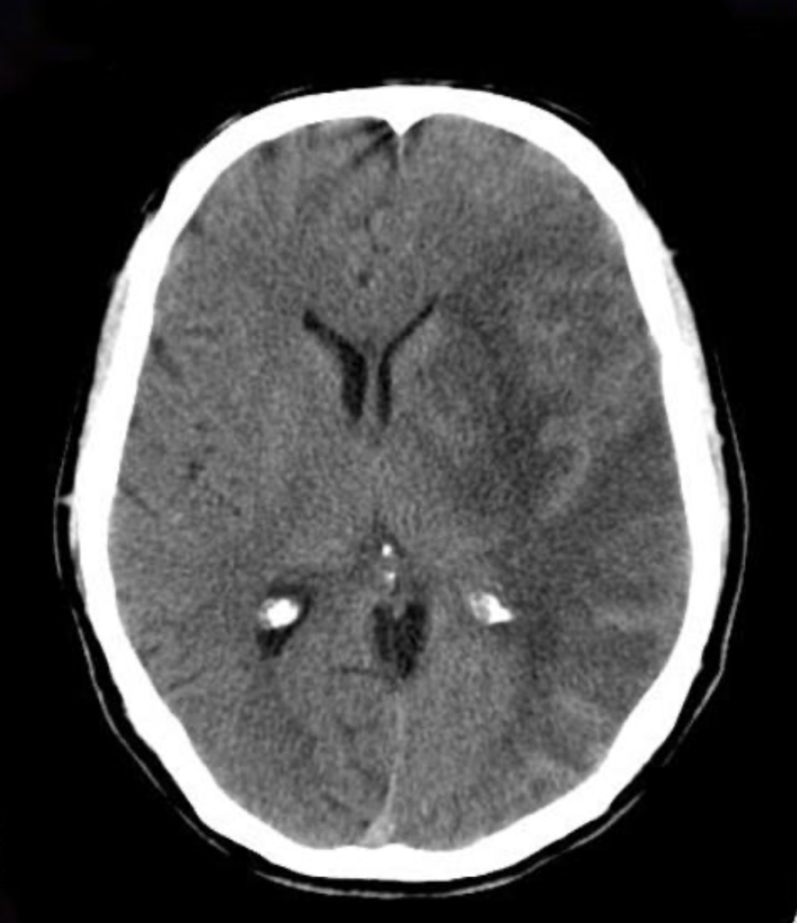

Loss of grey-white differentiation with oedema and mass effect in the territory of the left middle cerebral artery.

<https://radiopaedia.org/cases/left-middle-cerebral-artery-territory-infarct-1#image-139045>

**Thalamic lacunar infarct**

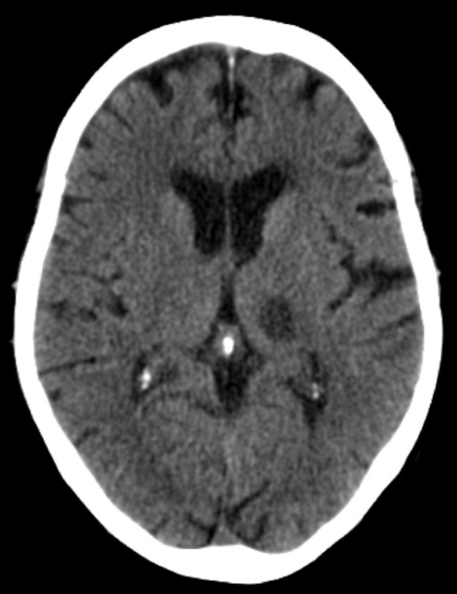

Interval evolution of the left thalamic hypodense focus which is currently more conspicuous, and appears larger, well defined and hypodense. No other signs of complication are evident

<https://radiopaedia.org/cases/thalamic-lacunar-infarct-1#image-12354665>

**Pontine infarct**

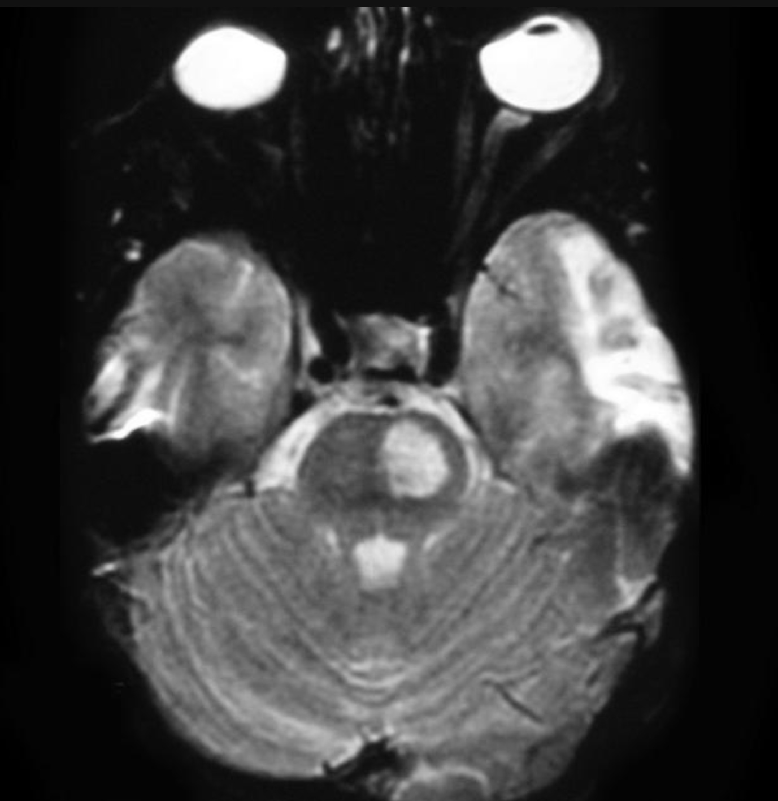

(T2w image) High (FLAIR: not incl)/T2 signal within the left hemipons (with increased DWI signal: not included). Note how the abnormality spares the very outer parts of the pons and does not cross the midline.

<https://radiopaedia.org/cases/pontine-infarct#image-31648>

**Basal ganglia hemorrage**

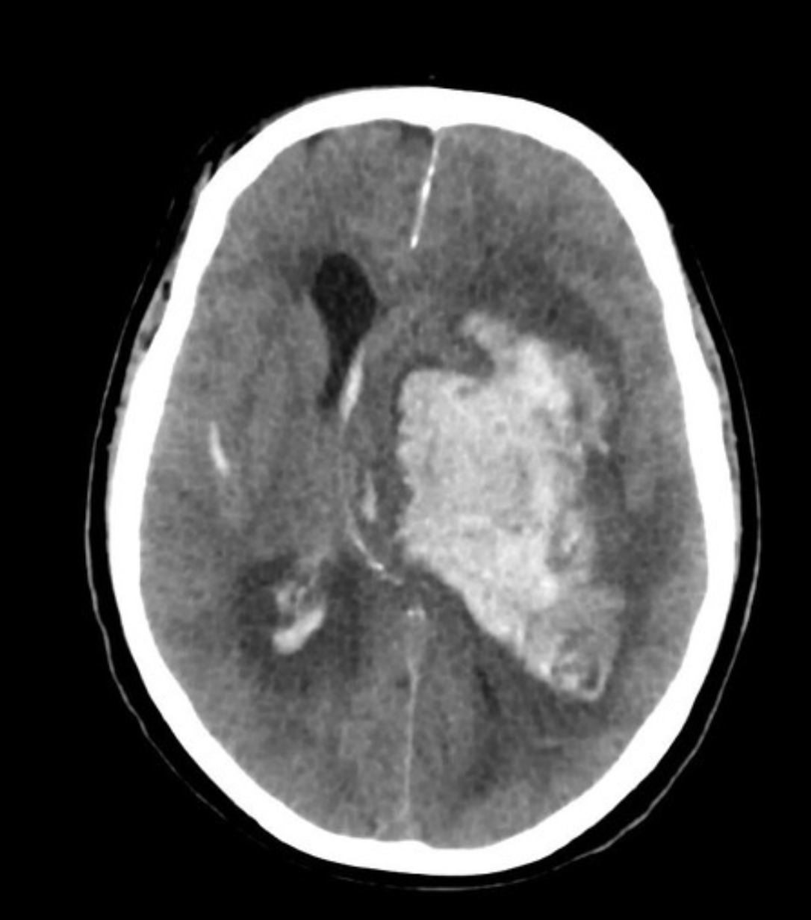

Large left sided intracerebral haematoma. It involves both deep (basal ganglia and thalamus) and parietal white matter. Its epicentre is within the left basal ganglia. The haemorrhage extends into the intraventricular and subarachnoid spaces.

There is significant mass effect relating to the haematoma causing midline shift, compression of the third ventricle and partial effacement of ipsilateral cortical sulci. The temporal horns of the lateral ventricles are dilated in keeping with hydrocephalus.

CT angiogram shows no aneurysm, arteriovenous malformation. or spot sign.

<https://radiopaedia.org/cases/basal-ganglia-haemorrhage-10#image-36636619>

**Lobar hemmorqage**

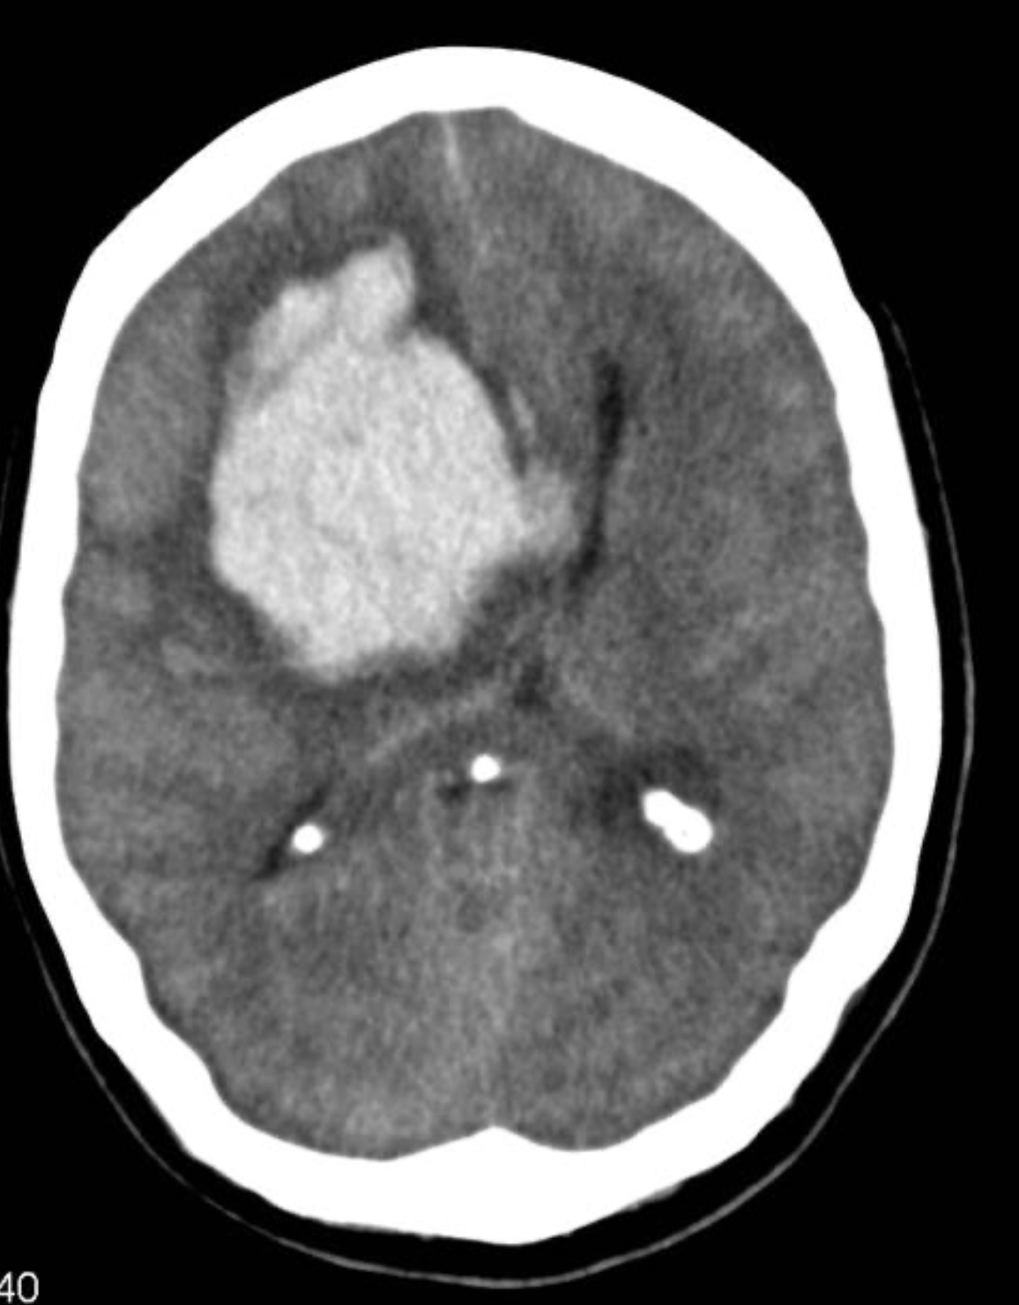

CT without contrast demonstrates a very large lobar haemorrhage occupying most of the frontal lobe and extending into the ventricles. It exerts marked positive mass effect.

On the left there is evidence of a previous infarct.

<https://radiopaedia.org/cases/lobar-haemorrhage#image-540478>

**Hepatocellular carcinoma metastasis to meningioma (tumour-to-tumour metastasis)**

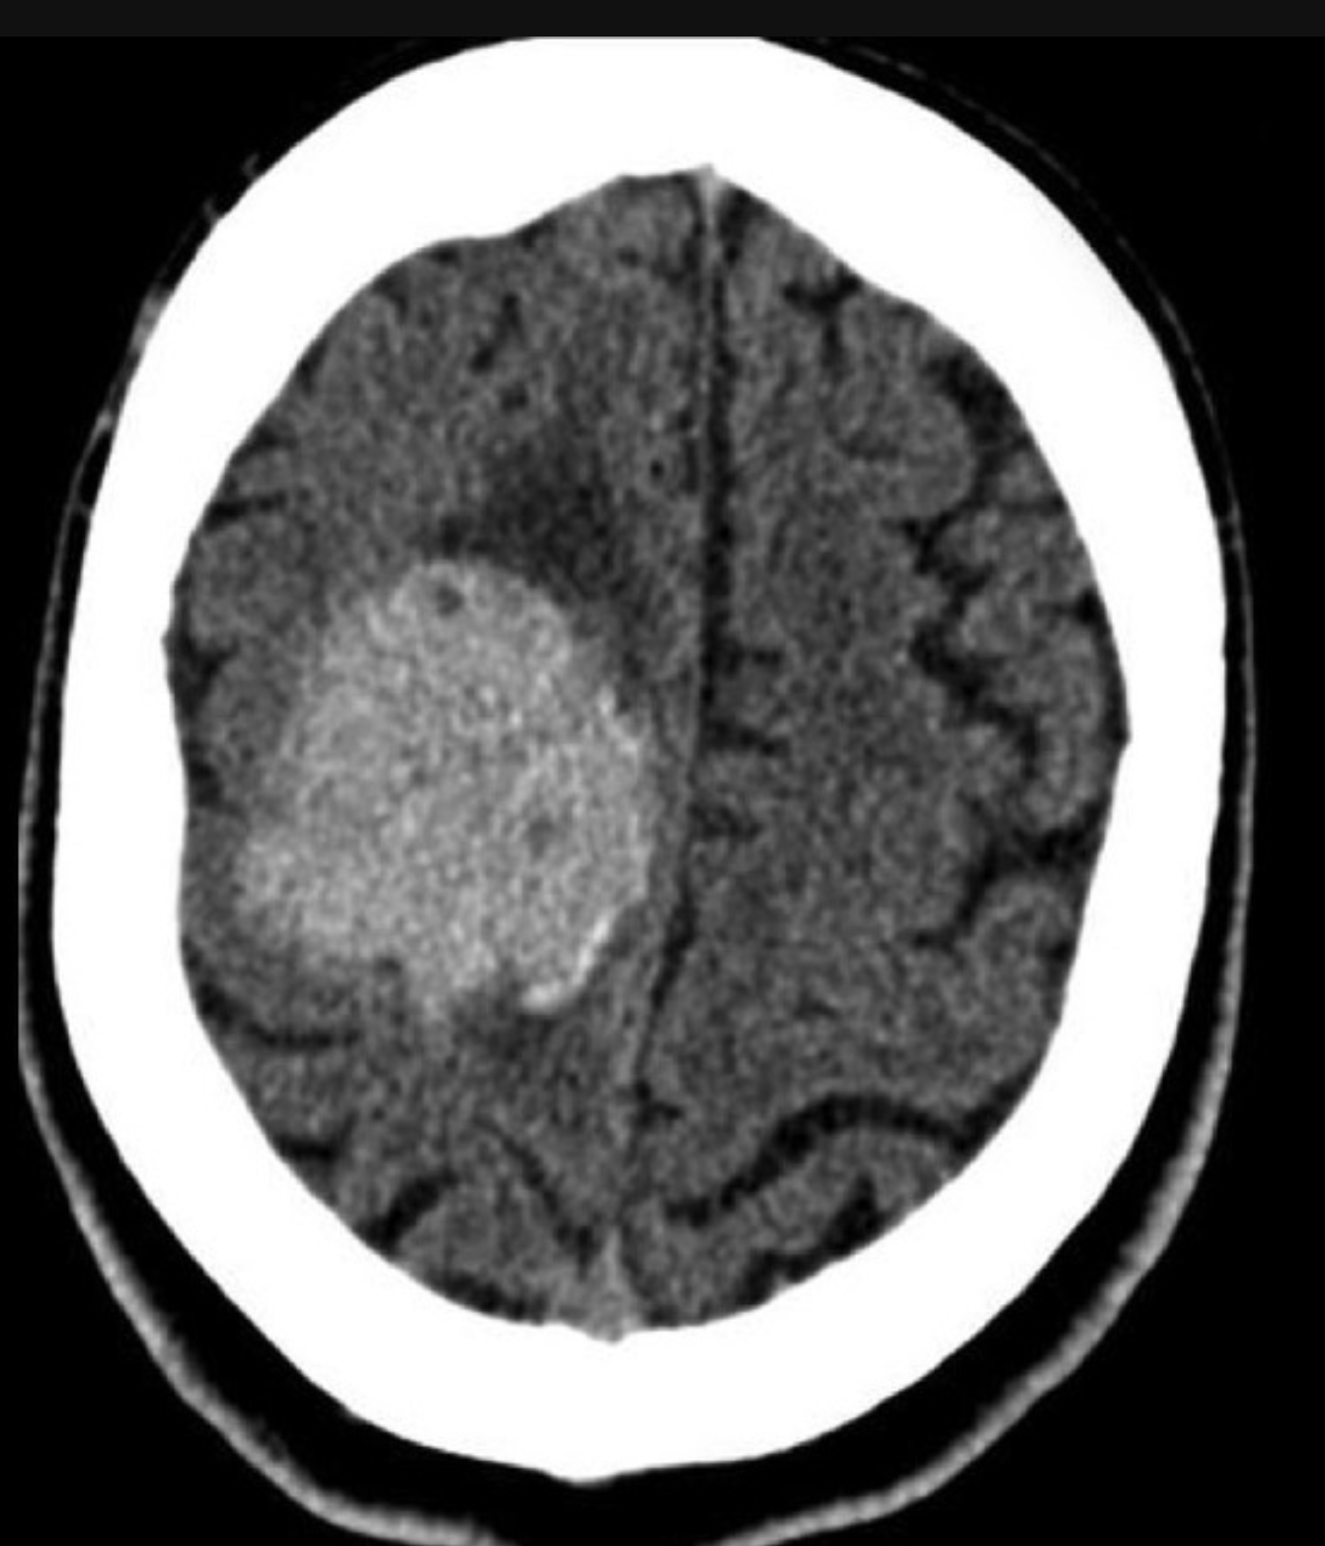

Extra-axial mass with hyperdense crescent posteroinferiorly suggestive of blood.

<https://radiopaedia.org/cases/hepatocellular-carcinoma-metastasis-to-meningioma-tumor-to-tumor-metastasis#image-19183797>

**Lung carcinoma metastasic to a brain meningioma**

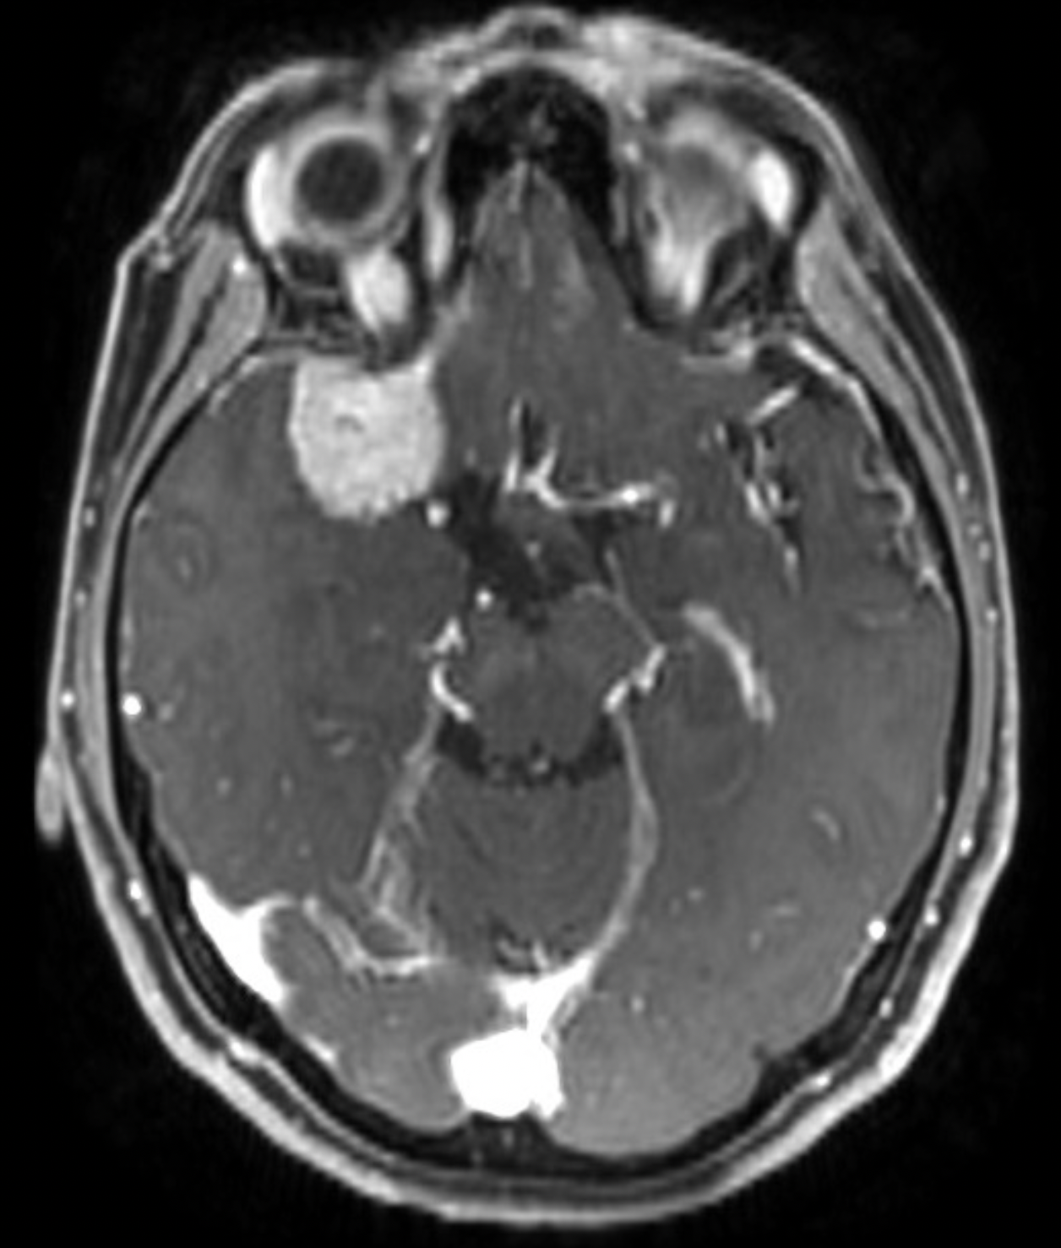

The right middle cranial fossa is again demonstrated with features that suggest a meningioma.

https://radiopaedia.org/cases/lung-carcinoma-metastasic-to-a-brain-meningioma#image-15977030